B.TECH. (2020-24)
Artificial Intelligence

Lab File
on
Digital Electronics and Computer Organization
[CSE207]

Submitted To
Ms Neha Arora

Submitted By
Hitesh
A023119820027
4CSE11 (AI)

DEPARTMENT OF COMPUTER SCIENCE AND ENGINEERING
AMITY SCHOOL OF ENGINEERING AND TECHNOLOGY
AMITY UNIVERSITY UTTAR PRADESH
NOIDA (U.P)

OPEN ENDED
AIM
To study and design a 4*4- bit array multiplier

PLATFORM/TOOL USED
- Simulator: https://circuitverse.org/simulator

THEORY
An array multiplier is a digital combinational circuit used for multiplying two binary numbers by employing an array of full adders and half adders. This array is used for the nearly simultaneous addition of the various product terms involved. To form the various product terms, an array of AND gates is used before the Adder array.

Checking the bits of the multiplier one at a time and forming partial products is a sequential operation that requires a sequence of add and shift micro-operations. The multiplication of two binary numbers can be done with one micro-operation by means of a combinational circuit that forms the product bits all at once. This is a fast way of multiplying two numbers since all it takes is the time for the signals to propagate through the gates that form the multiplication array. However, an array multiplier requires many gates, and for this reason it was not economical until the development of integrated circuits.

Checking the bits of the multiplier one at a time and forming partial products is a sequential operation that requires a sequence of add and shift microoperations. The multiplication of two binary numbers can be done with one microoperation by means of a combinational circuit that forms the product bits all at once. This is a fast way of multiplying two numbers since all it takes is the time for the signals to propagate through the gates that form the multiplication array. However, an array multiplier requires a large number of gates, and for this reason it was not economical until the development of integrated circuits.

SIMULATED OUTPUT
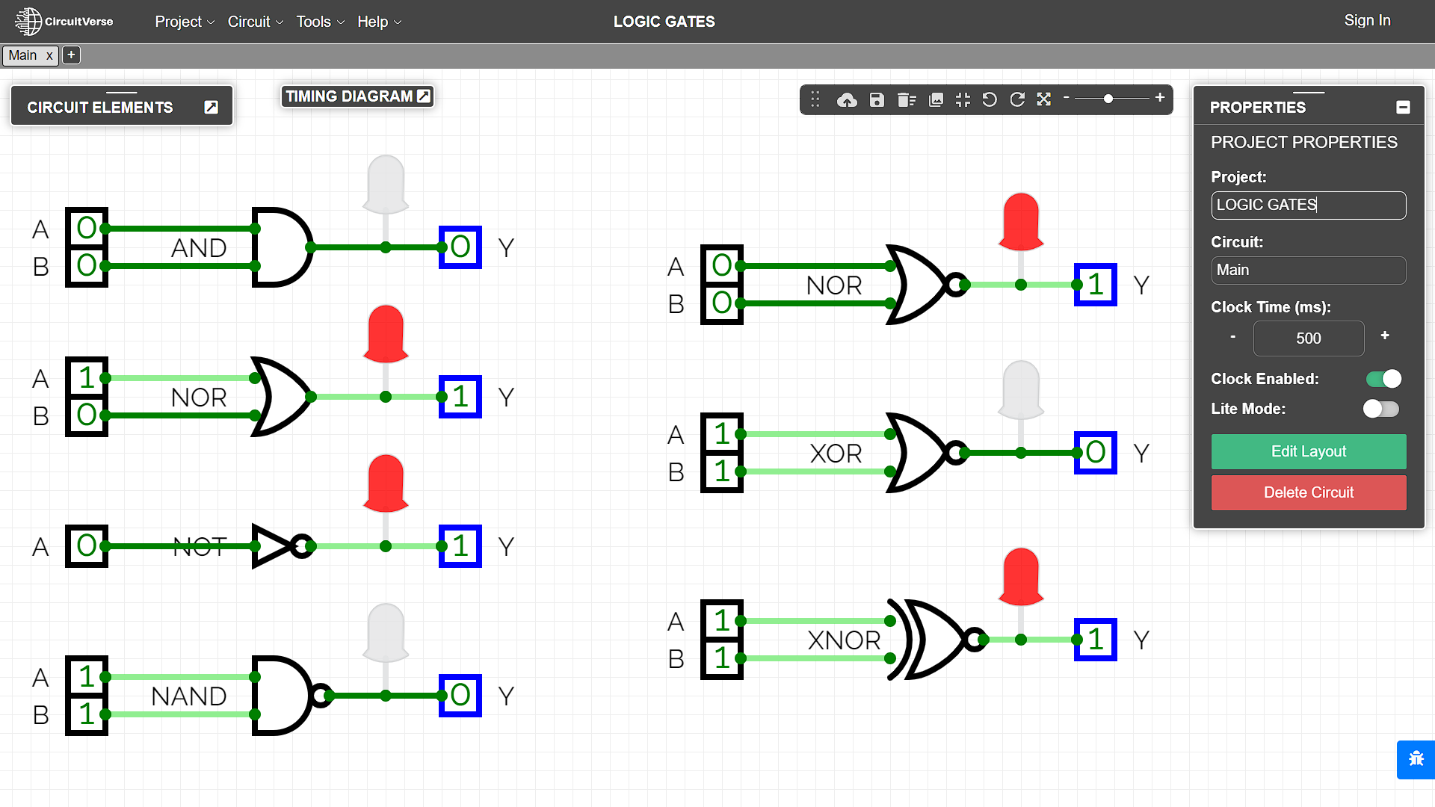

RESULT
The Boolean Expressions and Truth Tables of Logic and Universal gates have been studied and verified using the online simulator.

